43

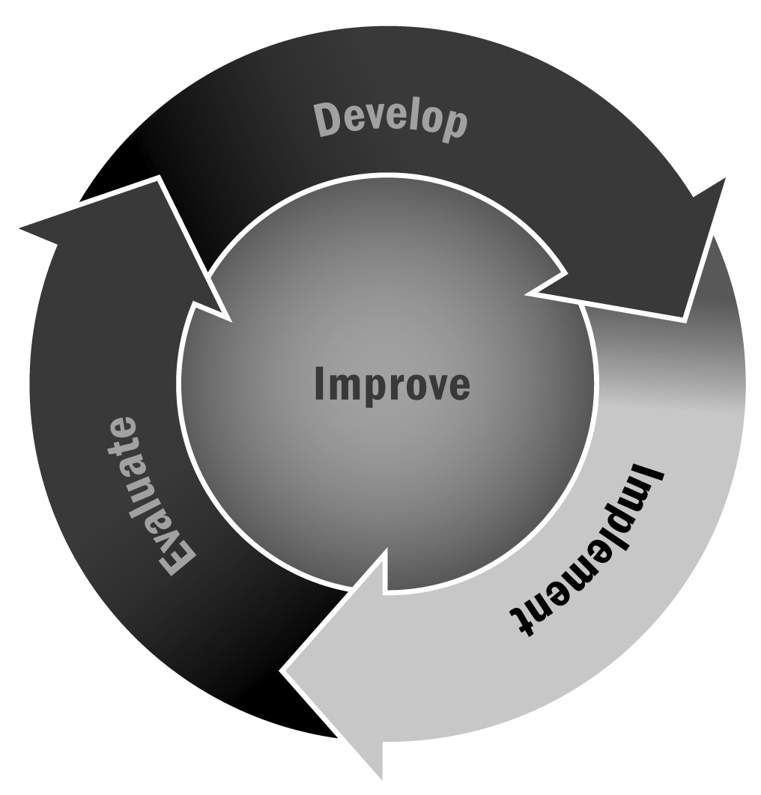
Sample Memorandum of Understanding
In Chapter 3, you learned how important it is to make sure you and your partners are on the same page. Clearly articulating expectations and writing them down is recommended for all partnerships.
Directions: Develop a memorandum of understanding to set expectations for your community partners and your program. The following example memorandum can be adapted to help you outline who will be responsible for what activities. It will be particularly helpful in avoiding misunderstandings and ensuring continuity if there is turnover in either organization. Make sure that the signers have the authority to commit the time or resources of each entity.
[Agency/organization] will partner with [names of schools] participating in [program name], and commits to do the following:
- If the organization is committing volunteers, list the number of volunteers it is willing to commit, how many hours per week, and for how long. If you will provide some training for those volunteers, list it here.
For example: “ABC Organization commits to providing five hours of volunteer service per week. Volunteers will go through a brief reading tutoring program offered by Neighborhood School.”
- If the organization is committing supplies, list that commitment here.
For example, “ABC Organization will provide extra paper and other office supplies to the program as available.”
- If the organization is committing time by providing one of its representatives to sit on your advisory board, list that commitment here.
For example, “John Smith from ABC Organization will join the Advisory Board meeting on XX/XX/XXXX.
He will attend XX meetings and will have the following responsibilities: _________________________________.”
- List any other commitments that the agency or organization is willing to make to your program. These commitments could include advertising, community relations, and solicitation of further funding opportunities.
[Agency/organization] sees its role as assisting [program name] in reaching its goals, and will be as flexible as possible to accommodate any special needs or changes. In turn, [program name] will be flexible in accommodating the concerns of [agency/organization].

Signed this _______________ day of _______________, 20_______________

________________________________________________ ________________________________________________
Agency/Organization Representative School/Program Representative

